# Description

I want to create an enhanced notepad app built off of my app 2. The first page will contain a list view showing the titles of the notes and a small image of a plus icon at the bottom that you can push to add a new note. When the button is pushed the user will be taken to a second page which will let them fill out the title of the note and the note contents. When a title in the list view is clicked on the first page the app will open up another page showing the title at the top and the note content in a label. I will be using the Android platform to develop my application.

# Layout

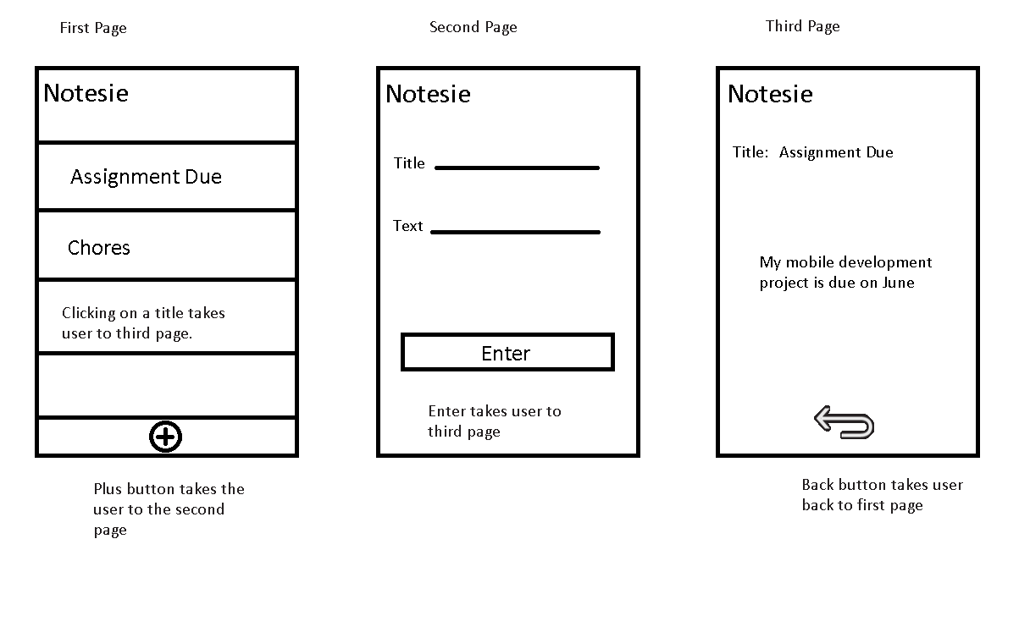

# XML

## First View

<Notesie>

<NotesView>

<Title

text = "Notesie"

id = "title">

</Title>

**<LINEBREAK/>**

<ListView

id = "notes"

width = "wrap content"

action = "openNote">

</ListView>

**<LINEBREAK/>**

<Button

id = "addNote"

action = "addNote">

</Button>

</NotesView>

</Notesie>

## Second View

<Notesie>

<NotesView>

<Title

text = "Notesie"

id = "title">

</Title>

**<LINEBREAK/>**

<TextField

id="userInput"

input="Title">

</TextField>

**<LINEBREAK/>**

<TextField

id="userInput"

input="Text">

</TextField>

**<LINEBREAK/>**

<Button

id = "enterNote"

action = "enterNote"

image = "plusButton">

</Button>

</NotesView>

</Notesie>

## Third View

<Notesie>

<NotesView>

<Title

text = "Notesie"

id = "title">

</Title>

**<LINEBREAK/>**

<TextField

id="noteTitle">

</TextField>

**<LINEBREAK/>**

<TextField

id="noteText">

</TextField>

**<LINEBREAK/>**

<Button

id = "backButton"

action = "backView"

image = "backButton">

</Button>

</NotesView>

</Notesie>

# Data Flow Diagram

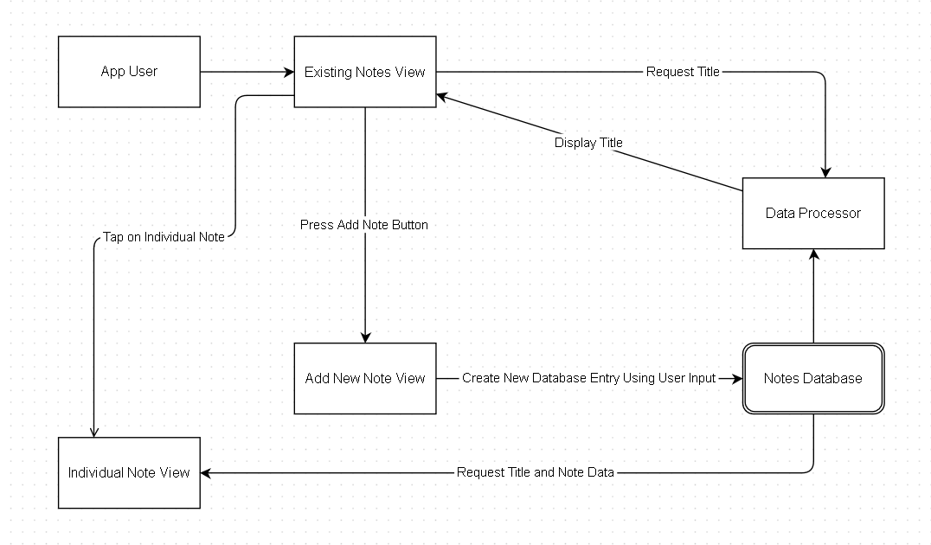

# Control Flow Diagram

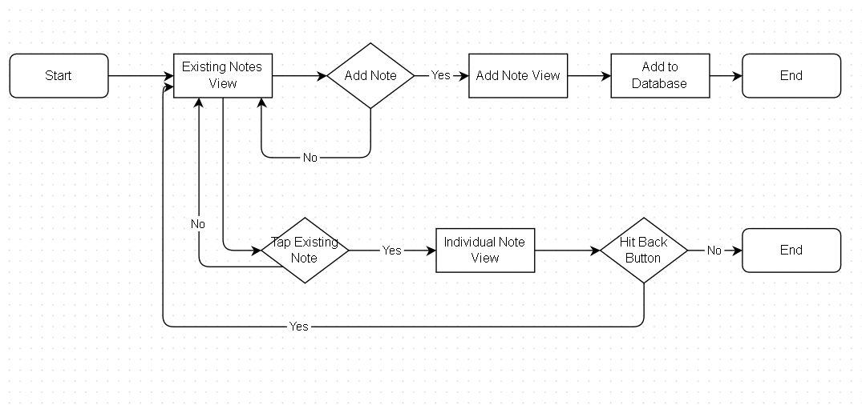

# Persistent Data

Each note will have an integer key and two strings to hold both the title and the note text.

|  |  |  |  |
| --- | --- | --- | --- |
| **Column** | Key | Title | Note |
| **Data Type** | Integer | Text | Text |